# 

# Dashboard Display User Testing Report

**Team Visteon**

Suzana Arellano

Scott Tsuchiyama

Chisheng Li

## Introduction

This report is focused on a usability study conducted with potential users to evaluate the performance of our dashboard display design. From this, we aim to establish a qualitative understanding of how drivers use the dashboard design. In particular, we are interested in answering the following questions:

* Do participants understand how to interact with the proposed dashboard display?
* Do participants recognize the icons, labels, and alerts displayed?
* How are participants using the proposed dashboard display?
* What are the types of things drivers look for on the dashboard display?

## Methodology

## Prior to beginning testing, we created a script (see Appendix A) in order to identify the process for our usability tests. The script included a preamble in which the moderator introduced her/himself and the project, outlined the process, and described the process of thinking aloud while doing tasks. In addition, at the end of the preamble, the moderator reassured the user by reiterating that we were testing the system rather than the user him/herself, and encouraged the user to let us know if they wished us to stop the test at any time due to concerns or discomfort.

In addition to the preamble, we created a series of tasks for the users to complete. Because conducting a test of our system in an actual car would have been impractical, we devised a way to keep users focused on a separate primary task while they were passively/actively engaging with our prototype dashboard display system. We required the user to drive a car around (in first-person view) within the game "Grand Theft Auto IV" for their primary task. In front of the user, slightly below the field of view, we placed a laptop computer with the dashboard display prototype. For portions of the usability test, we also placed an iPad to the user's right (next to the laptop) to represent our design for the integrated the center-stack display/console.

The main portion of the usability test was broken down into two sections, one to mimic the user's interaction with the system while the car is in park, and another to replicate the interaction while driving. Before beginning the assessment, we had the user play the video game on its own, in order to gain a basic familiarity with the controls. While we wanted different experience levels with this game (in order to represent varying levels of driving experience), we wanted users to have at least a baseline understanding of how to play the game so as not to unfairly burden them.

To begin the assessment, we asked the user to play around with both the dashboard display and center-stack device as if they were testing out a new and unfamiliar car. They were instructed to view all the options and press buttons, describing what they anticipate each interaction will accomplish. After recording this feedback, we walked the user through the system, confirming or correcting their assumptions in order to help them understand what each element represents.

For the second half of the test, the users began playing the video game while we changed the system display to represent driving at the speed limit, above the speed limit, and alert notifications (such as "low fuel"). We asked the users to notify us when they noticed those changes, and followed-up with questions about how many mph over the speed limit they were driving, or what the alert was about.

Finally, at the end of each test, we conducted a post-questionnaire in order to debrief the user. The post-questionnaire focused on assessing the user's overall impression of the system, asking their likes and dislikes, where they were confused or overwhelmed, and the level of difficulty in using the system.

As mentioned above, we recruited users that had differing levels of experience playing video games, in order to represent the most and least experienced drivers in our personas. For instance, we felt that, like experienced drivers, experienced gamers would feel more comfortable with their primary task, impacting the way they interact with the secondary/tertiary task (our dashboard display system).

Each test was led by one moderator and observed by one note-taker. A third group member managed the dashboard display, changing its presentation to represent changes that would occur in the act of driving. After all the tests were completed, the team gathered to debrief the results and notes, and discussed possible changes to alleviate the challenges users faced with the system.

## **Participants**

Five participants took part in the 2-day study on November 13 and 14 ,2011 in the residence of one of our team members. All participants were recruited from our acquaintances and friends.

Testing with each participant lasted approximately 45 minutes. Participants’ demographics are as follows:

|  |  |  |  |  |  |  |  |  |
| --- | --- | --- | --- | --- | --- | --- | --- | --- |
| **#** | **Gender** | **Age** | **Profession** | **Driving Experience** | **How often do you refer to your dashboard display?** | **For what purpose do you check your dashboard?** | **Do you multitask while you drive?** | **Persona** |
| 1111 | M | 18-29 | Dentist | 11 yrs | Sometimes | To check speed and gas level, and to set cruise control | Sometimes | Allison Otto |
| 2 | F | 18-29 | Student | 7 yrs | Often | To check speed limit and gas level, and to know what alert is on; seldom aware of the RPM | Sometimes | Allison Otto |
| 3 | M | 40-49 | Student | 16 yrs | Seldom | To check speed | Always | Allison Otto |
| 4 | F | 18-29 | Student | 6yrs | Sometimes | Speed and gas level | Always | Carter Benz |
| 5 | M | 30-39 | Student | 9yrs | Sometimes | To maintain constant speed | Often | Robert  Shoreham |

The last column on the table above labeled “Personas” matches our participants with our personas. Each participants was matched to the persona they represented the most in terms of demographics and user needs in relation to the dashboard display.

## Study Results

**Summary of Key Findings & Issues**

**Some users experienced confusion with the labels. In particular, the “display manager” button.**

* Three of the five participants had a different understanding of the purpose of this option.
* Most participants did not know what to expect after selecting the “display manager” option.
* A few participants asked about the limitations of the “display manager” button. They were not sure when the display manager option was available and when it was off limits. Without prompting, a user suggested “you should remove the display manager button [from the dashboard display] when it’s off limits, or when the car is in drive”

**Reaction to alerts**

* All participants noticed when they has a new alert
* All participants clearly understood when they were going over the speed limit
* Most participants expressed they could not interpret the gas level indicator accurately. One participant stated“ the gas level is red, its indicates low gas level, but it does not give me a percentage or a number, so I don’t know exactly how much gas I have left. I want to be able to decide when the gas level is low enough for me to pull over and get gas”
* When the icon indicated low gas level, participants acknowledge it, but they did not click on the gas icon to get more information. At least one participant said” I would not expect to click the gas icon to get the location of a nearby gas station”
* Most users had no trouble acknowledging a new alert on the dashboard while keeping their attention on the road.
* Most drivers did not look away from the video game for more than two seconds

**Look and feel of design**

* All users appreciated the simplicity of dashboard display
* “I like the use of color”
* “the information is very clear”
* “I like the options”

Overall, participants responded positively to the dashboard design. When participants were asked if they would use the dashboard display in real life, all stated that they would. The ratings for the content, layout, and appearance of the dashboard were also positive. Three of five participants rated the dashboard display as a 4 or 5. The rating scale used was from 1 to 5 where 1=Poor & 5= Excellent.

## Participant 1:

**Task1: Understanding the interface and its visual appearance**

The participant considers the dashboard design to be standard when compared to dashboards in existing cars, and finds the display easy to read. He can easily articulate the functions of each icon and the color coding selected for the alerts. He wants to have a clock-hand speedometer as an improvement, and rates the dashboard display at 4.

The participant finds the iPad display to be informative with the car’s current condition. However, he does not consider the city/highway mileage breakdown useful. Instead, he wants more information on what is the top speed that the driver has reached, and a broader breakdown on how often the driver travels below and over the speed limit. Participant also rates the center stack display at 4.

**Task 3:** **Video Game Interaction**

The participant is focused on his task generally, but quickly notices the change of displays in front of him and easily understands the new information when he is speeding or the car has low level of gas. Participant wants a percentage estimate on the gas level so that he can estimate how much further he can travel, and wants to be able to click on the gas icon to find out more information on the head-up display to locate the nearest gas station. Also, he feels that the alert flashes too quickly and he has to stop to read the text alert on the dashboard display.

Overall, the participant likes the simple interface because the display is not confusing or distracting. He does not feel overwhelmed, but wants additional alert icons such as seat-belts alert to be placed onto the display. He likes the idea where the dashboard display only shows alerts that require attention, and the center stack interface to provide a more detailed information.

**Participant 2:**

**Task1: Understanding the interface and its visual appearance**

The participant’s immediate reaction was to press on the “Full display” icon because she expects the function will enable the dashboard display to tell her everything about the car. She toggles with the display manager and assumes that closing (pressing [x]) all the customizable icons will be the same as turning the full display off. Participant expects the gas icon to tells her how many miles she can drive before the gas becomes empty, and feels that a percentage estimate will not be useful to her. She rates the dashboard display design at 5.

When participant reads the iPad interface, she knows that a red-color alert demands immediate attention and will not ignore the alert. Participant likes the GPS links to car mechanics, but wants to know if the mechanics are available to fix the car without scheduled appointments. Participant also wants to understand why some alerts are yellow instead of red, and when each alert will change from yellow to red. Participant wants an exact breakdown on how often the car travels at what speed over the speed limit. Despite the improvements that she has suggested, the participate gives a 5 rating to the center stack display.

**Task 3:** **Video Game Interaction**

Generally, the participant notices when a new alert appears, but cannot remember the original dashboard display that is shown at stationary mode. Participant expects the speedometer to show a red bar as soon as she travels beyond the speed limit. She does not find the icons to be distracting, but wants to know if she can use the “display manager” function even when she is driving. Participant also wants to know if she can voice activate the GPS navigation system while she is driving.

Overall, the participant is pleased with the features of the dashboard display that emphasizes on safety awareness and enables customization. She wants the GPS system on the center stack to be usable even when she is driving, or a button on the steering wheel that can activate the GPS function. Participant wants the center stack touchscreen interface to be closer to the passenger seat. She also wants a similar city/highway breakdown for the car’s speed records, and the bar that emphasizes on speeding to be more conspicuous.

**Participant 3:**

**Task1: Understanding the interface and its visual appearance**

The participant considers the display features to be instinctive, and he is pleased that the tachometer is removed. Because he is already used to fixed dashboard displays, he is not interested in toggling with the display. Participant is concerned that the steering wheel may obstruct with pressing any icon on the dashboard display, and he is not in favor of interacting with the dashboard display. Participant gives the dashboard display design a 3 rating.

On the other hand, he likes the iPad interface especially because of the links to the GPS data. However, he does not want the iPad interface to be fixed onto the center stack, but to have it detachable so that he can move it closer to read the text. Participant rates the iPad interface at 4.

**Task 3:** **Video Game Interaction**

The participant initially did not notice the change of display until he was asked about the number of alerts that he sees. This is mainly because of he generally does not refer to the dashboard display when he drives. However, he adds that if the speedometer is dynamic and fluctuates, he will easily perceive the difference. Participant knows that he is driving too fast once the red bar appears, and added that he wants additional cues (such as music) to inform him how much over the limit he is, and to remind him to decelerate. He remarks that our dashboard display design has plenty of space even when the full display is on, and does not perceive too much difference in reading the information when the clutter is reduced.

**Participant 4:**

**Task1: Understanding the interface and its visual appearance**

The participant is not attracted by the display design and finds it normal compared to regular car dashboard display. She is confused on how she can return to the original display after toggling with the “full display” and “display manager” icons. However, she feels that the display shows just the right amount of information and does not feel overwhelmed. She rates the design at 4.

The participant feels that she will not read the information on the center stack touchscreen to know what is wrong with the car, but she likes the GPS information so that she can take the car to a mechanic immediately. She does not mind having a city/highway breakdown on her mileage, but is unimpressed by the feature. She rates the touchscreen interface at 4.

**Task 3:** **Video Game Interaction**

The participant is focused on the primary task and takes a few moments to notice the initial display change. However, she is able to immediately articulate the information that she perceives from the new alert. She is more comfortable when the full display is off so that she can concentrate on just the speed limit and the gas level. Participant expects information on the nearest gas station to be automatically activated on the head-up display as soon as the gas is below a threshold level and turns red.

The participant likes the simplicity of the dashboard display design, but otherwise does not find any feature to be unique. She is unable to give any suggestion on what improvement can be made to the design.

**Participant 5:**

**Task1: Understanding the interface and its visual appearance**

The participant complains about the lack of alerts on doors, seat belts and the anti-braking system. He considers alerts about the transmission and oil change to be low priority and does not require frequent attention. He wants an estimated mileage to be presented directly beside the gas icon, and rates the dashboard design at 3.

The participant wants the iPad interface to record and provide a log of his driving history such as recent destinations in the past 7 days. However, he does not appreciate the long information on car maintenance such as why regular oil change is vital. Instead, he proposes the center stack interface to show a figure of the car, with each part of the car to light up (in yellow or red) when attention is required. Participant rates the iPad interface at 3.

**Task 3:** **Video Game Interaction**

The participant easily perceives the less cluttered display, but feels that it looks very empty. Due to the emptiness, he proposes to shut off the dashboard display once the car is in motion, and instead present the information on speed, gas level and alerts on the head-up display. He remarks that the alert texts flashes too quickly and wants to be able to read the new alert clearly before it minimizes itself. He does not want to interact with the dashboard display when he drives, but he wants the iPad interface to remains interactive even while the car is in motion. Participant does not need the display toggle function, and wants the full display to remain off throughout the drive.

Overall, the participant feels that the dashboard display presents the barest minimum amount of information that will assist his driving. As a result, he is not confused nor overwhelmed by the information that he sees. Because the GPS navigation system is the primary function that he wants on the iPad interface, he asks if the interface’s screen size can be diminished to be fitted onto the center of the steering wheel instead of the center stack.

Appendix

**Appendix A: Protocol**

**Introduction & Preamble**

1. **Introduce yourself:** Hi, I‟m __[state name]__. Thank you for agreeing to help us out today.

2. **What we’re doing today:** We’re assessing a new design for a digital automobile dashboard display system. You have been invited to help us test a prototype of our dashboard display design, and to give us feedback. We will do this in two stages:

* 1. I will have you view and interact with the system as you would if the “car” were parked. We will ask for your opinion what each of the icons does. We will then walk through the features, so that you are clear on what each element is and what it does.
  2. I will then begin a driving simulation exercise, and we will observe how you interact with the system. This exercise will take about [x] minutes. You will play a video game as your primary task (to represent driving a car), and we will ask you to view and interact with the display prototype as needed. Once the test starts, I will be observing over your shoulder, but I will not be able to answer any questions.

3. **Think aloud:** As you work through the exercise, please articulate all of your thoughts. It is really important for you to say what you are thinking as you perform each task. Some of the things that we‟d like you to keep in mind as you work:

* Please remember to tell me what you are thinking.
* Please tell me, why did you stop?
* What are you thinking as you perform the task?
* What were you expecting to see?
* What are you looking for?
* What are you doing right now?
* How do you feel while performing the task?
* Why are you skipping to the next task?

**Reassure them:** I‟d like to be clear that we‟re assessing the product, not you, so please don‟t worry if you can‟t get something to work, or dislike any aspect of the product -- those are exactly the sorts of issues we‟re trying to uncover. You aren‟t under any pressure to continue, and *you can stop at any time.*

*Do you have any questions before we begin?*

To start, I’d like to ask you a few questions about yourself…

**User #__________**

|  |  |
| --- | --- |
| Gender: | □ Female □ Male |
| Age Range (years): | □18-29 □30-39 □40-49 □50-59 □60+ |
| Profession: |  |
| Do you drive? |  |
| Driving Experience (years): | □0 □1-2 □3-5 □6-9 □ 10+ |
| How often do you refer to your dashboard display? | □Never □Seldom □Sometimes □Often □Always |
| For what purpose do you check your dashboard? |  |
| Do you multitask while you drive? | □Never □Seldom □Sometimes □Often □Always |

**Task1: Understanding the interface and its visual appearance**

Please take a moment to review the content on this interface. Feel free to click into any of the areas. Then we’ll discuss in a moment.

* What do you think the main purpose of this interface is?
* Please describe each element on the interface and tell me what you think its function is?
* What do you think? Did you encounter any issues?
* What do the colors on this interface communicate to you?
* How would you describe the visual appeal of this interface?
* Where would you click to interact with this interface?
* Would you use this interface in real life? If not, what would you use instead?
* What 3 improvements can be made to this interface?
* Overall, on a scale of 1-5, how would you rate this interface in terms of content, layout and appearance? ( 1=poor, 5= excellent)

**Task 2: Familiarize the user with the interface**

* Describe the purpose of the following elements:
  + color scheme
  + alerts
  + speedometer
  + display manager

**Task 3:** **Video Game Interaction**

* Now, i will give you a few minutes to play a {name of game} video game. Have you played this video game before? Y| N
* As you are playing the game i will ask you a few questions. Please remember to “think aloud” as you perform this task and to pay attention to this (ipad) interface.
* **Action Pattern:**
  + **how many alerts do you see on this interface? ( only display two)**
  + **[press accelerate]**
    - Does the user notice when he/she is accelerating? Y| N
  + **[ask “currently, how many mph are you driving over the speed limit?”]**
  + **[press new alert]**
    - Did the user notice the alerts? Y|N
    - Did the user press the button to find nearest gas station? Y|N
  + **[toggle additional display elements ‘on’]**
  + **[press new alert]**
    - Is it easier, more difficult, or the same to notice a new alert with the extra clutter?

**Post-Questionnaire**

-What is your general impression of the interface?

-Where you at any point confused?

-Did you feel overwhelmed by the information displayed?

-Do you have any additional feedback or comments about anything you saw today that you’d like to share?

**Appendix B: Screen shots of interface**

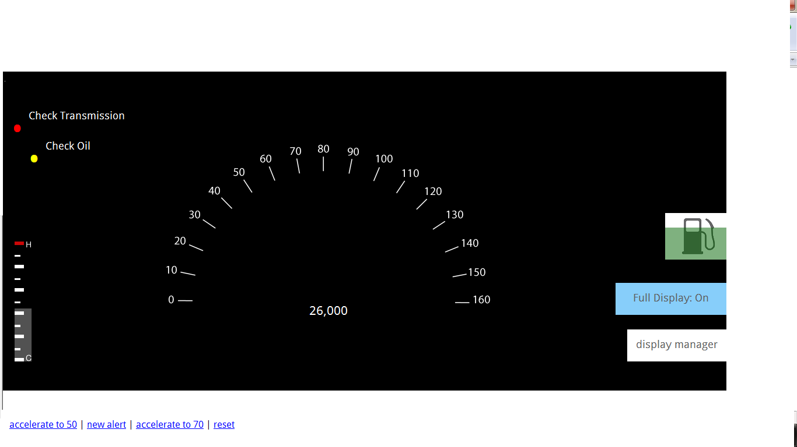

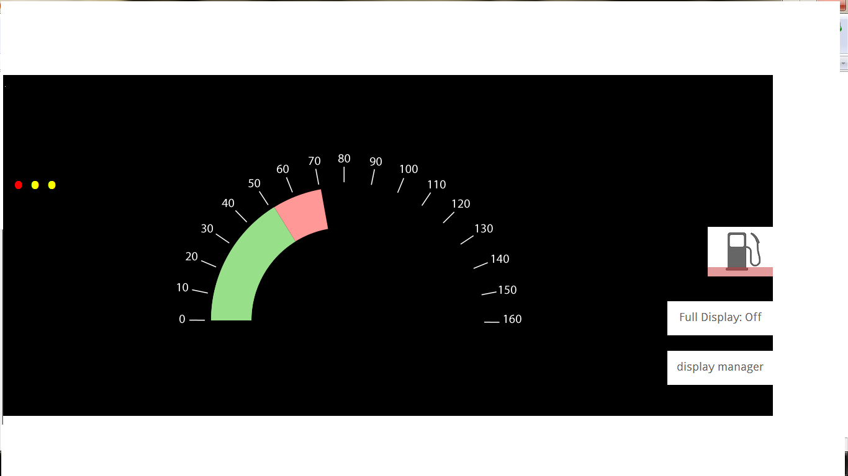

Image3.Center Stack

The purpose of this element is to provide information to the user while the car is in park.The user can use this interface to view recent driving statistics, input information into the GPS, and to learn about the car (including any problems).

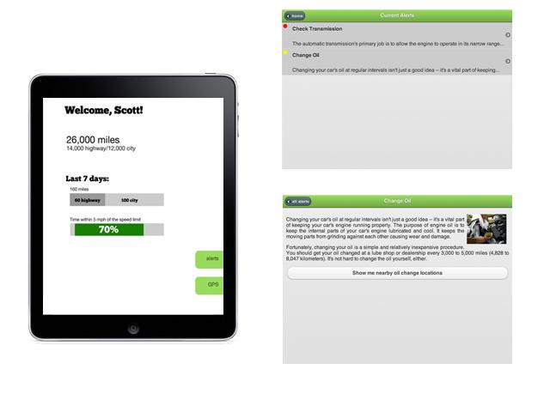

**Appendix C: Personas**

Persona 1: Carter Benz

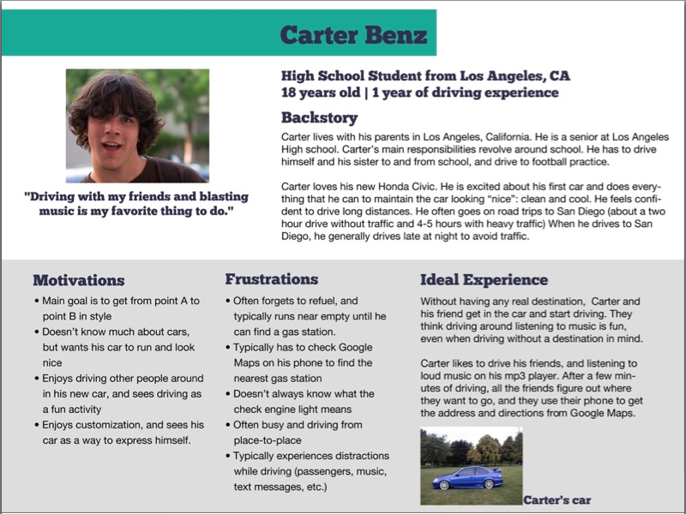

Persona 2: Allison Otto

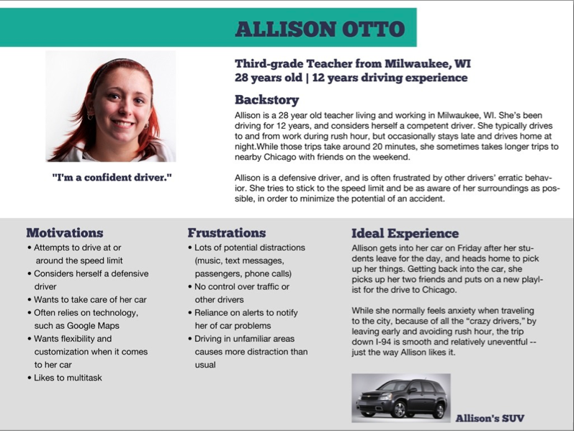

Persona 3: Robert Shoreham

